Standard PPE Requirements For Department

Steel toe cap footwear is required for the department operation, whether these be in the form of boots or shoes, both are acceptable. Please contact you production manager immediately if you do not have the correct footwear. | 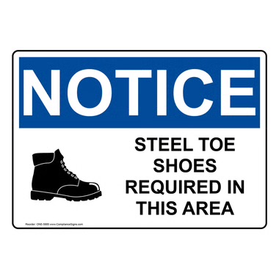
Ear protection is provided at the entrance to the department and is a requirement during production activity times. Please contact your production manager immediately if you require alternative hearing protection. | 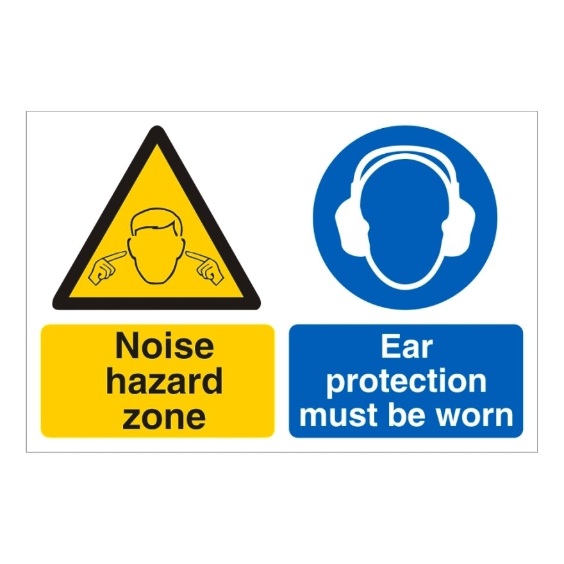

Key Purpose of The Procedure

To ensure that all employees can operate to their trained standard, RM7 employees must follow these operating procedures to ensure all risks to injury are minimised throughout a daily shift. Pre-shift checks MUST be completed before each production day and any defects/concerns must be highlighted immediately to the department manager. The below MUST be understood and followed,

- All emergency stop buttons MUST be in a correct working order before production starts. These are located on the reel stands, ink tower, sheetgate area, squareback unit, main control, delivery, baler and all the wrappers and shrink tunnels
- Check that all door guards on the machine are closed and that the machine CANNOT be operated whilst these are open
- Check that all the ink trough lids are secure and that the safety sensors are all working

General Working Environment

RM7 is an active exercise book machine department in which there are many moving parts and employees undertake tasks during the daily operation. Many tasks require a clear understanding and a trained operator to ensure the production can be completed safely. These include the operation of machines in all areas of the department. The general operation is set below,

- One operator to control/run the machine and manage the departments output
- One machine assistant to the main operator
- One operator to change reels and operate the reel stands
- One employee piling down
- One Forklift/Warehouse operator

Each task/role requires the understanding of the safety aspects surrounding each machine. And, that these are followed and communicated during their training and followed once signed off.

Reel Stand Safety

RM7 reel stands operate a twin web system that, once reels are in place, can be spliced to the next with operator intervention to do so. Preparation around new reels, waste reels and servicing is reliant on the reel stand operator. This role requires a clear understanding of low hanging moving parts, reel positioning and training around the machine controls console. The operation side of the reel stands is part of the reel stand training procedure, but risks are still present. All operators MUST,

- Be fully trained on how to operator the reel stands
- Understand where the emergency stops are located (Main console and at the end of each reel stand)
- Keep the area free from obstacles and waste at all times
- Communicate with the forklift operator if access to the reel store area is required

Any defects or unsafe situations must be communicated to the main machine operator or the department manager.

Entering the Delivery (Pile ups)

The below MUST be followed in the event of a ‘pile up’ within the delivery area. These points are to ensure any intervention is done safely,

- Engage the stop button to stop the machine
- If books are piled up, follow the delivery procedure to safely remove books
- Communicate to all staff that an intervention is occurring
- When the pile up is clear and any issues that may have caused the pile up have been resolved, ensure the delivery has been returned back to the operational standard before restarting

Wrapper Operation

The Wrapper has many moving/dangerous parts whilst the machine is in operation. This risk is reduced due to the door guard sensors in place which isolate the Wrapper if opened. The below is still a risk and the following procedure must still be followed,

- Whilst in operation all wrapper guards must be closed and in safe position including the one on plastic reel unwinder unit.
- Guard on the book turning unit should be closed and locked into position.
- If intervention is required around the sealing plates, ensure that extra vigilance is taken when removing excessive plastic. Ensure time is given for this area to cool down
- The temperature of the shrink tunnel should not exceed 200c.

